Galaxy Defender: Solar System

--- Minimum Requirements ---

This software has been tested and runs on Samsung Galaxy Note GT-N7000 and later models, with Android 4.0 (API level 14) or greater.

--- Introduction ---

Aliens are invading our solar system in search for habitable planets and they are not friendly. Therefore, it is your duty to save the human race from extinction by fighting against them with your spacecraft. Your mission starts close to Neptune where you must destroy as many enemy ships as possible. From there you'll travel to different planets where alien activity has been reported.

The aliens will try to outsmart you with different tactics, so you must not forget the current objective, which will be explained on your way towards each planet.

To commence your mission, simply press NEW GAME.

--- Game Controls ---


Press on the arrow buttons to move your spacecraft left and right. You must dodge both enemy ships and enemy projectiles. No barrel rolls can save you here.

A laser beam is constantly fired from you spacecraft. In addition to the laser, you may fire missiles and electromagnetic pulses (EMP), which temporarly disables electronics. These are activated by pressing on the corresponding button.
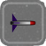


EMP Missile
Each weapon may be upgraded after you have saved a planet. By doing this, the weapon effectiveness is increased. However, upgrades aren't free. Use points that are earned by destroying enemy ships.

--- Gameplay ---
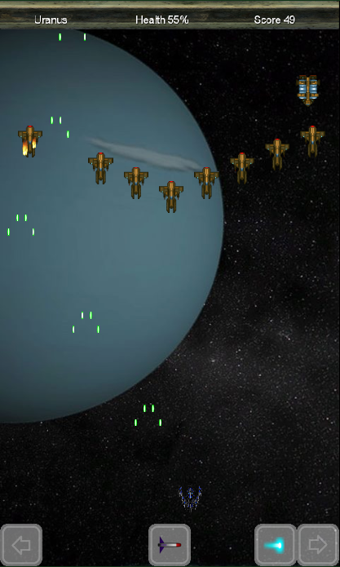
In the upper bar of the screen you'll see the current stage, your health in percentage and your score. You'll die if your health drops to zero. If it does, you must start from the beginning again, but if your score is sufficiently high, you might end up on the highscore list.

You have two possible controller layouts, which can be toggled in the Options-menu (press OPTIONS in main menu). In here you'll also be able to toggle backgroundmusic, soundeffects and vibration.

Control Layout 1:


Control Layout 2:


If you press the HIGHSCORE-button in the main menu, you'll be able to see a top 13 highscore list. Battle with your friends to see who scores the highest.

